- Draw a labeled diagram of a typical home Wi-Fi setup showing a modem, router, switch, access point, and at least two devices (like a laptop and smartphone) connected to the network.
Ans :-
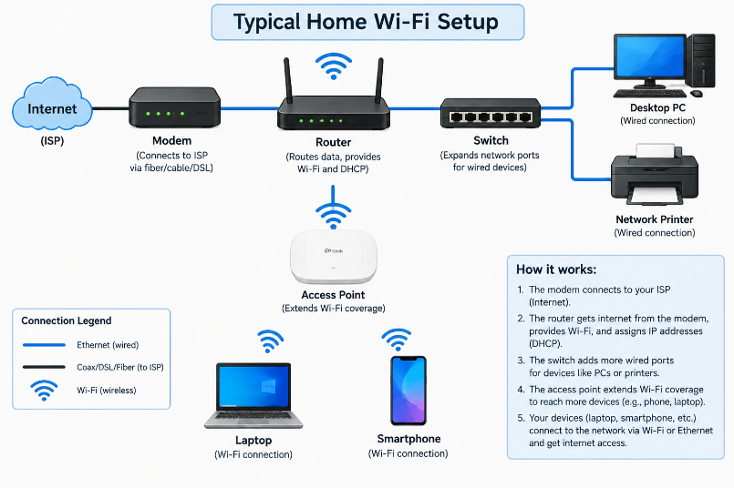

- List the main function of each networking hardware device: modem, router, switch, access point, and network cable. For each, give a real-life example of where you might see or use it (for example, 'router: at home to share internet').
Ans :-
Device | Main function | Real-life example
Modem | Connects a home or office network to the internet service provider (ISP). | A modem used for a home broadband connection.
Router | Connects different networks and directs data between them. It can share internet with multiple devices. | A Wi-Fi router used at home to connect phones and laptops to the internet.
Switch | Connects multiple wired devices within the same local network (LAN). | A switch connecting computers in a college computer lab.
Access Point (AP) | Provides Wi-Fi connectivity to wireless devices. | An access point providing Wi-Fi in a school or office.
Network Cable | Carries data between network devices through a physical connection. | An Ethernet cable connecting a desktop computer to a router.

- Take photos or find images online (with source links) of at least three types of network cables (such as Ethernet, coaxial, fiber optic) and write one line describing where each is commonly used.
Ans :-

A. Ethernet cable
Ethernet cables are commonly used to connect computers, printers, switches, and routers in homes, offices, and computer labs.

B. Coaxial cable
Description: Coaxial cables are commonly used for cable television, satellite connections, and some broadband internet services.

C. Fiber-optic cable
Description: Fiber-optic cables transmit data using light and are commonly used for high-speed internet, telecommunications, and long-distance network connection.

- Create a comparison table listing at least four differences between a router and a switch, including their main use, typical location, and how they handle data.
Ans :-
No. | Feature | Router | Switch
1 | Main use | Connects different networks, such as a home network to the internet. | Connects multiple devices within the same local network (LAN).
2 | Typical location | Commonly used in homes, offices, and internet networks. | Commonly used in offices, computer labs, and server rooms.
3 | How it handles data | Forwards data packets between networks using IP addresses. | Forwards Ethernet frames within a LAN using MAC addresses.
4 | OSI layer | Mainly operates at Layer 3 (Network Layer). | A typical managed or unmanaged Ethernet switch operates at Layer 2 (Data Link Layer).
5 | Internet connection | Often connects a local network to the internet. | Usually connects devices to each other within a local network.
6 | Example | A home Wi-Fi router connects laptops and phones to the internet. | A switch connects several desktop computers in a college computer lab.
7 | Wireless support | Many home routers provide Wi-Fi connectivity. | Most standard Ethernet switches provide wired connections only.
8 | Address used | Uses IP addresses to decide where to forward packets. | Uses MAC addresses to forward frames to the correct device.

